**Tree species composition of the study landscape**

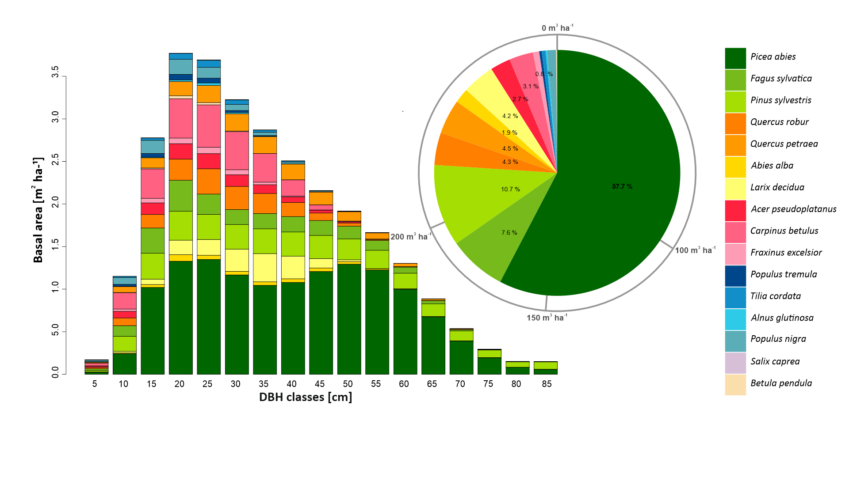

Figure 1. Initial tree species composition of the study landscape from year 2015. Species proportions are calculated based on the species-specific growing stock.

**Species-specific browsing probabilities used in the simulations**

Table 1. Species-specific browsing probabilities used to drive forest development simulations. Breference represents original browsing probabilities implemented in iLand derived from the Austrian National Forest Inventory. The original values for *Acer* spp. (**bold**) did not correspond with the current situation in the region and were modified based on the available literature (Černý et al. 2011, Fuchs et al. 2021, Šebeň et al. 2017), Czech Forest Inventory data, and consultation with local experts (increased from 0.30 to 0.71, comparable to *Quercus* spp.). Bexlusion represents a browsing exclusion scenario with all probabilities set to 0. Bmoderate represents browsing Breference reduced by 50%. The number of years a species endures browsing before the species cohort dies out.

|  |  |  |  |  |
| --- | --- | --- | --- | --- |
| **Species** | **Bexclusion** | **Bmoderate** | **Breference** | **ST [years]**\* |
| *Picea abies* | 0.00 | 0.03 | 0.06 | 3 |
| *Abies alba* | 0.00 | 0.35 | 0.71 | 5 |
| *Larix decidua* | 0.00 | 0.18 | 0.35 | 3 |
| *Pinus sylvestris* | 0.00 | 0.17 | 0.34 | 3 |
| *Fagus sylvatica* | 0.00 | 0.24 | 0.48 | 3 |
| *Quercus robur* | 0.00 | 0.36 | 0.71 | 3 |
| *Acer pseudoplatanus* | 0.00 | 0.36 | **0.71** | 2 |
| *Fraxinus excelsior* | 0.00 | 0.33 | 0.65 | 2 |
| *Carpinus betulus* | 0.00 | 0.33 | 0.66 | 3 |
| *Betula pendula* | 0.00 | 0.33 | 0.65 | 2 |
| *Quercus petraea* | 0.00 | 0.36 | 0.71 | 3 |
| *Alnus glutinosa* | 0.00 | 0.27 | 0.53 | 2 |
| *Populus tremula* | 0.00 | 0.27 | 0.53 | 2 |
| *Populus nigra* | 0.00 | 0.27 | 0.53 | 3 |
| *Tilia cordata* | 0.00 | 0.33 | 0.65 | 3 |
| *Salix caprea* | 0.00 | 0.27 | 0.53 | 2 |
| *Robinia pseudoacacia* | 0.00 | 0.33 | 0.65 | 3 |

*ST – Browsing Tolerance, the number of years a species endures browsing before the cohort dies out (unpublished data)

**Used climate projections**

Table 2. Used Regional Climate Models, driving Global Climate Models, and developing institutions.

|  |  |  |  |
| --- | --- | --- | --- |
| **id** | **Abbreviation** | **Global Climate Model (GCM)** | **Regional Climate Model (RCM)** |
| 1 | MPI-CCLM | MPI-M-MPI-ESM-LR | CLMcom-CCLM4-8-17 |
| *Max Planck Institute for Meteorology* | *Climate Limited-area Modelling Community* |
| 2 | NCC-HIRHAM5 | NCC-NorESM1-M | DMI-HIRHAM5 |
| *Norwegian Climate Centre* | *Danish Meteorological Institute, Denmark* |
| 3 | EC-EARTH-RACMO22E-r1 | ICHEC-EC-EARTH | KNMI-RACMO22E |
| *Irish Centre for High-End Computing* | *Royal Netherlands Meteorological Institute, De Bilt, The Netherlands* |
| 4 | HadGEM2-CCLM | MOHC-HadGEM2-ES | CLMcom-CCLM4-8-17 |
| *Met Office Hadley Centre* | *Climate Limited-area Modelling Community* |

Figure 2. Temperature-precipitation space with the position of used climate projections. Average mean temperature and annual precipitation for 2071-2100 are shown (orange and red signs). A reference value for 1961-1990 (a black star) is indicated. Dashed crosses represent the multi-model mean of each RCP scenario.

**Wind parameters and disturbance dynamics**

Three windstorm series were used to drive the simulations. The wind speeds correspond with the wind speed distribution measured at the meteorological station located in the study area. Wind directions correspond with the prevailing wind directions of the region. The timing of the events was set randomly, apart from the major event set in the year 2070, because it was used as a reference to calculate the recovery time after a major disturbance. A series of wind backgrounds was also used. These winds are much smaller than the three major wind events, reproducing the effects of little storms.

Table 3. The sequence of wind events and their parameters during the 80-year simulations, the wind time series intensity is equal in all three scenarios, while CO2 changed based on the RCPs scenarios. In bolt you can find the three major winds.

|  |  |  |  |  |  |
| --- | --- | --- | --- | --- | --- |
| Simulation year | Day-of-year of wind occurrence | Wind speed  (m s-1) | Wind direction (°) | Wind duration (min) | Number of iterations |
| 4 | 355 | 5.9 | 208.0 | 87 | 10 |
| 6 | 120 | 6.7 | 346.0 | 62 | 7 |
| 9 | 276 | 6.1 | 204.0 | 40 | 5 |
| 10 | 319 | 6.8 | 221.0 | 58 | 7 |
| 13 | 171 | 6.0 | 354.0 | 39 | 5 |
| **16** | **294** | **14.0** | **337.0** | **89** | **10** |
| 17 | 180 | 7.5 | 297.0 | 50 | 6 |
| 19 | 177 | 5.2 | 300.0 | 49 | 6 |
| 25 | 156 | 5.2 | 199.0 | 44 | 5 |
| **29** | **314** | **11.0** | **45.0** | **72** | **8** |
| 30 | 153 | 7.4 | 147.0 | 33 | 4 |
| 34 | 281 | 7.1 | 227.0 | 88 | 10 |
| 35 | 227 | 6.1 | 7.0 | 81 | 9 |
| 40 | 128 | 5.1 | 199.0 | 64 | 7 |
| 41 | 94 | 5.7 | 174.0 | 37 | 5 |
| 46 | 286 | 6.4 | 254.0 | 55 | 7 |
| **50** | **301** | **19.0** | **10.0** | **138** | **15** |
| 54 | 189 | 6.8 | 167.0 | 32 | 4 |
| 58 | 295 | 6.1 | 307.0 | 87 | 10 |
| 59 | 165 | 5.7 | 197.0 | 58 | 7 |
| 62 | 87 | 5.5 | 309.0 | 89 | 10 |
| 65 | 178 | 6.6 | 156.0 | 68 | 8 |
| 66 | 139 | 5.7 | 126.0 | 50 | 6 |
| 69 | 61 | 5.3 | 167.0 | 53 | 6 |
| 72 | 180 | 7.5 | 297.0 | 50 | 6 |
| 74 | 11 | 6.1 | 215.0 | 89 | 10 |
| 76 | 102 | 6.7 | 251.0 | 68 | 8 |
| 78 | 107 | 6.6 | 318.0 | 38 | 5 |

**References**

Černý, M. et al. 2011. Inventory of forest damage from game to forest economy of the Czech Republic. Institute for Forest Ecological Research. Ministry of Agriculture of the Czech Republic. <https://www.uhul.cz/wp-content/uploads/ZZ_ISZ_2010_bez_priloh.pdf>

Fuchs, Z., Vacek, Z., Vacek, S., Gallo, J. 2021. Effect of game browsing on natural regeneration of European beech (*Fagus sylvatica* L.) forests in the Krušné hory Mts. (Czech Republic and Germany). Central European Forestry Journal 67, 166-180

Šebeň, V. 2017 National Forest Inventory of Slovakia 2015-2016. Information, methods, results. National Forest Centre, ISBN: 978-80-8093-234-3